Shell scripting

types of shell

Variable

Input parts output

Operator

Condition statment

If statment

If else statment

If elif else statment

Neasted if else statment

Simple shell scripting program on this part

Types of shell

Sh secure shell >>>> only have auth for root other user have not permission

Ksh kone shell >>>> root as well other user can do

Csh c shell >>>>>>support c program

Bash bourn again shell >>>> its contain all feature of all shell

Cat /etc/shell

Variable:-

Store value in it which can vary in nature.

Syntax :-**Var_name=value**

Rule:-

While writing only a-z and A-Z and 0-9 and special char only ‘_ ‘ only that support

(*%&@---not support)

Var_a  
_var_a /\

Types

Varibalename=123 vraiablename=456 >>>>>>normal which can vary in nature   
Readable variablename=123 >>>>>>final in nature   
unset var=123 >>>>notstable but assign to variable

**Take input and assign to variable**

Syntax-**read var_name**

Numerical 12 23

Integiare variable

Num1=123

Str=’ashitosh’

String :- alfabitical “ “ ‘ ‘ string

First script

Simple.sh

#!/bin/bash

num=25

str="ashitosh"

echo hello all my name is $str and my age is $num

#!/bin/bash

echo "what your name"

read str

echo "what your age"

read num

sleep 2

echo hello all my name is $str and my age is $num

operator

|  |  |  |  |
| --- | --- | --- | --- |
| Arthamatic operator  Used for perform artmatic operation | Relational operator  Used specific for numerica type | String operator  String comperission used |  |
| + ` expr $a + $b ` | == -eq equal to | = check string equal or not if yes then put true |  |
| * `expr $a - $b ` | != -nq not equal to | != not equal then condition become true |  |
| \* `expr $a \* $b ` | >= -ge grater than equal to | -z check string is not zero |  |
| / `expr $a / $b` | <= -le less tha equal to | -n non zero check where string is non zero |  |
|  | >. –gt grather than |  |  |
|  | < -lt less than |  |  |

Condition statement [ desion making statement ]

* If statement
* If else statement
* If elif else statement
* neasted if else statement

if statment

If [[ command ]]

then

Statement

fi

if else statment

if [[ command ]]

then

statement

else

statement

fi

if elif else statement

if [[ command ]]

then

statement

elif [[ command ]]

then

statement

else

statement

fi

#!/bin/bash

echo "what is your age:"

read age

if [[ $age -ge 18 ]]

then

echo "you are eligiable"

fi

#!/bin/bash

echo "what is your age:"

read age

if [[ $age -ge 18 ]]

then

echo "you are eligiable"

else

echo "you are not eligiable"

fi

if-elif else statment

#!/bin/bash

echo "enter num1"

read a

echo "enter num2"

read b

echo "enetr num3"

read c

if [[ $a -gt $b && $a -gt $c ]]

then

echo " num1 is grater number"

elif [[ $b -gt $a && $b -gt $c ]]

then

echo "num2 is grater number"

else

echo "num3 is grater number"

fi

************************************************

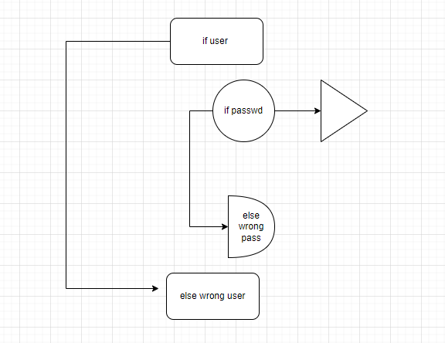

echo "enter your your username"

read usr

if [[ "$usr" == "ashitosh" ]];

then

echo 'enter your password'

read password

if [[ "$password" == "test@123" ]];

then

echo 'you are login successfully in system'

else

echo 'enter wrong password'

fi

else

echo 'you are enter wrong username'

fi